Milestone Four
Derick Silva
6/6/2026

Enhancement Three: Databases

This week I focused on enhancing my selected artifact, which is the Pet Boarding Application I originally created in IT-145: Foundation in Application Development, by fully integrating a relational database using SQLite. This artifact began as a very simple console-based Java program designed to intake basic pet boarding information. Although it was functional for that introductory course, it lacked the structure and features of a fully featured product.
For this enhancement, I fully integrated SQLite as the persistent data layer by designing relational schema that models real-world connections between Owners, Pets, and Stays. The Pets table includes a foreign key, owner_id, that links each pet to its corresponding record in the Owners table, ensuring referential integrity and enabling efficient joins when retrieving full owner/pet profiles. The Stays table extends this relationship by including the pet_id foreign key, allowing the application to track which pet is currently staying. These cascading relationships make it possible to load complete, interconnected datasets with a single query and maintain consistency when records are updated or removed. In addition to these tables, I implemented a separate Users table that is intentionally isolated from boarding data relationships. This table stores application login accounts, role assignments, and securely hashed passwords using PBKDF2 with salts. By separating authentication concerns from operational data, the system maintains a clean architecture while enforcing role-based access control. Together, these relational structures demonstrate my ability to design database schemas, enforce data integrity through foreign keys, and integrate secure user management into a multi-table database.
The course outcomes I planned to meet were:
“Demonstrate an ability to use well-founded and innovative techniques, skills, and tools in computing practices for the purpose of implementing computer solutions that deliver value and accomplish industry-specific goals.”
and
“Develop a security mindset that anticipates adversarial exploits in software architecture and designs to expose potential vulnerabilities, mitigate design flaws, and ensure privacy and enhanced security of data and resources. “
I fully met the first outcome through the way I integrated SQLite into the application using well-founded relational design principles and industry standard tooling. Designing the schema around real-world relationships between Owners, Pets, and Stays required me to evaluate different database modeling strategies and select the one that best supported performance, maintainability, and clarity. Implementing foreign keys such as owner_id in the pets table and the pet_id in the Stays table allowed the application to enforce referential integrity automatically and enabled efficient multi-table queries that deliver value to end users by returning complete, accurate information. I also fully met the second outcome by approaching the database layer with a security mindset. I isolated the Users table from the other relationships to reduce attack surface, stored passwords using salted PBKDF2 hashing, and ensured that role information is never mixed with operational data. This separation of concerns, combined with parameterized SQL statements and careful control over how user credentials are accessed, demonstrates my ability to anticipate common vulnerabilities such as SQL injection, privilege escalation, and improper data exposure. Together, these design choices show that I can apply secure, industry-standard techniques to build a relational data layer that is both robust and resilient. I have no updates to my outcome coverage plan, as I wrap this week up, I feel I have completed all 5 of the course outcomes.
This week I found myself so deep in building this application because I had time off from my day job. I spent so many hours this week working on things like adding functionality, polishing existing functionality, and finding/fixing bugs, not only because the weeks are running out, but because I really enjoy it. I found myself coding for hours, not realizing how much time had passed until I finally looked at the clock and had to force myself to step away and take a break. As the code base grew bigger, my constructors were getting bigger and I found myself needing to refactor my code to clean that up. There were a couple times where I had a NullPointerException because I was passing a UI element to another element, for the purposes of refreshing the UI after changes were made to a pet, before it was fully instantiated. These were hard to track down and made me realize I needed to keep all these elements in a single object, which I called AppContext. I created this class for the purpose of holding all my repositories and UI elements that might need to be refreshed when changes were made to a Pet, Owner, or Stay. With this, I was able to pass a single object to my classes that had everything they needed to do what they needed to do.

Overall, this week was both challenging and rewarding as I pushed my Pet Boarding Application closer to a fully realized software product that a pet boarding facility could probably use and find value in today. Diving deep into the database integration and refactoring the growing codebase helped me recognize how important clean architecture and thoughtful design patterns are as a project scales. Solving issues like NullPointerExceptions and constructor bloat forced me to rethink how components communicate, ultimately leading to me creating my AppContext class, which has already made the system more maintainable and predictable. I also rediscovered how much I genuinely enjoy building software. I would often look up from my screen surprised at how much time had passed. This week reinforced not only my technical growth but also my confidence in my ability to design, debug, and evolve a complex application.

Screenshots
Here is a screenshot my database schema in my DatabaseManager class
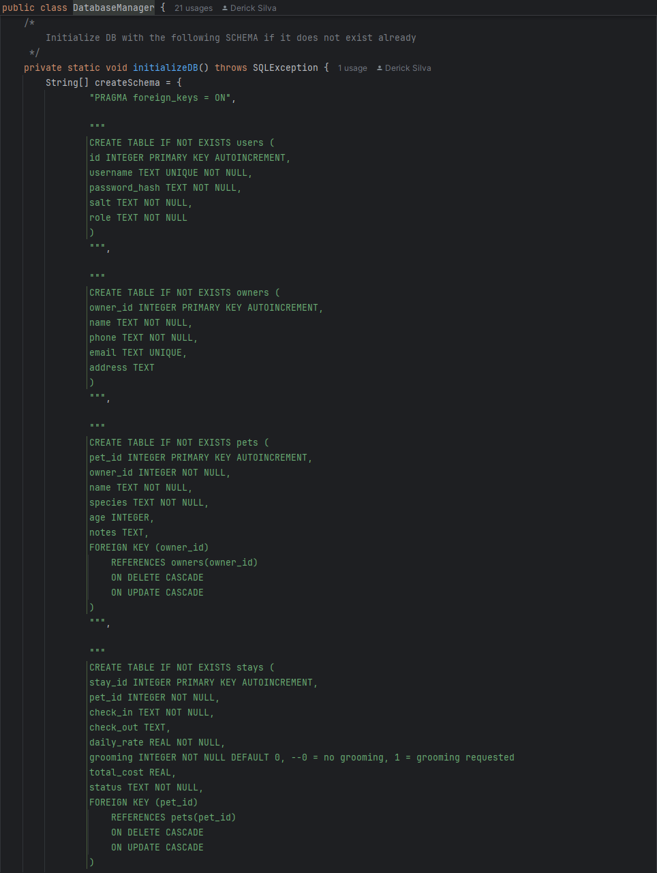
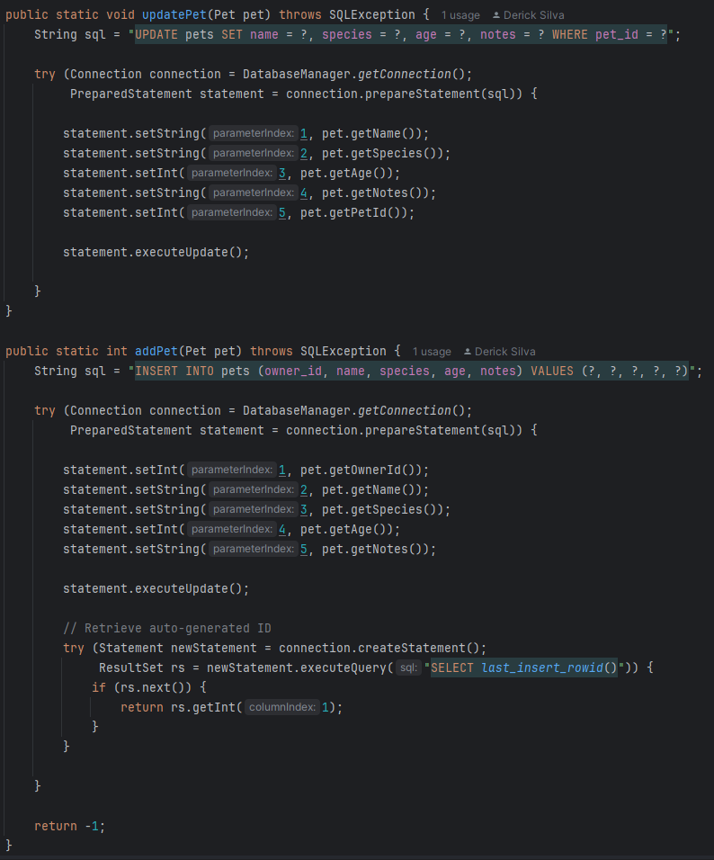
This is some of the CRUD operations in my PetDAO

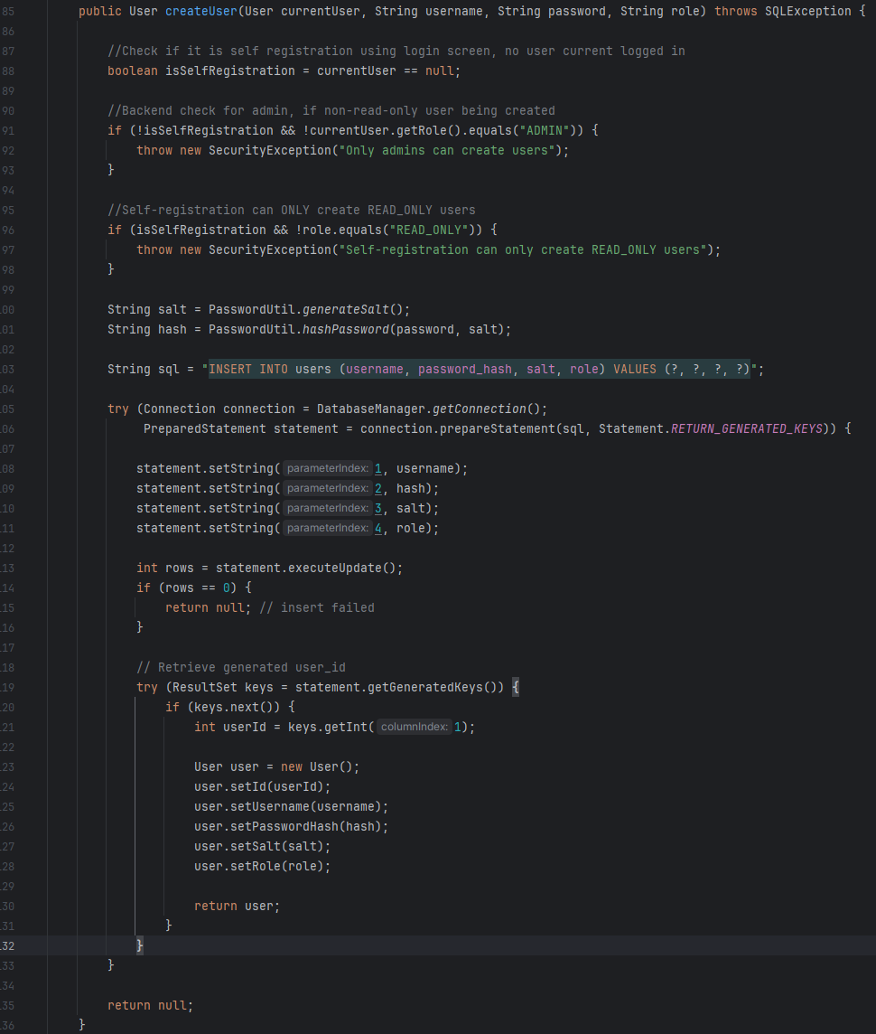
This is my createUser() method in my UserDAO. This shows how I am using prepared statements.
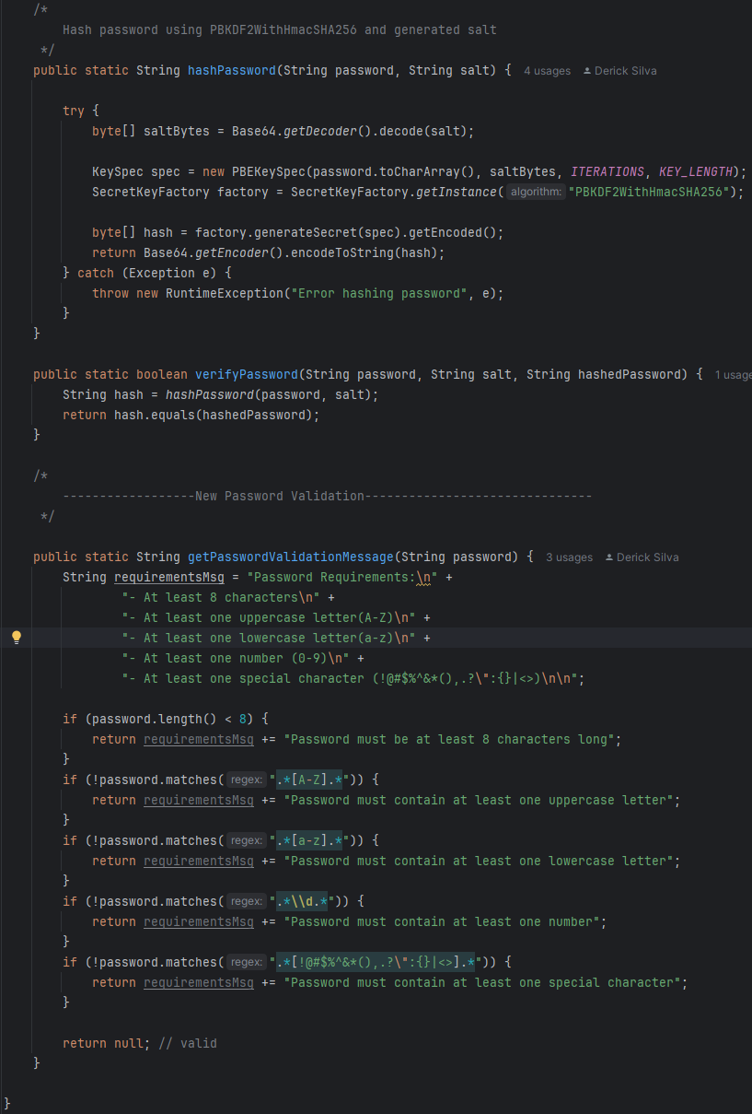
Here is a screenshot of my PasswordUtil, this shows how I implemented hashing and also the password requirements I implemented.

